IP = [58,50,42,34,26,18,10,2,
60,52,44,36,28,20,12,4,
62,54,46,38,30,22,14,6,
64,56,48,40,32,24,16,8,
57,49,41,33,25,17,9,1,
59,51,43,35,27,19,11,3,
61,53,45,37,29,21,13,5,
63,55,47,39,31,23,15,7]

FP = [40,8,48,16,56,24,64,32,
39,7,47,15,55,23,63,31,
38,6,46,14,54,22,62,30,
37,5,45,13,53,21,61,29,
36,4,44,12,52,20,60,28,
35,3,43,11,51,19,59,27,
34,2,42,10,50,18,58,26,
33,1,41,9,49,17,57,25]

def permute(block, table):
return ''.join(block[i-1] for i in table)

def xor(a, b):
return ''.join('0' if i == j else '1' for i, j in zip(a, b))

def des_encrypt(pt, key):
pt = permute(pt, IP)

left = pt[:32]
right = pt[32:]

for i in range(16):
right_expanded = right # simplified
temp = xor(right_expanded, key[:32])
new_right = xor(left, temp)

left = right
right = new_right

combine = right + left
cipher = permute(combine, FP)

return cipher

# Input
plaintext = "0000000100100011010001010110011110001001101010111100110111101111"
key = "0001001100110100010101110111100110011011101111001101111111110001"

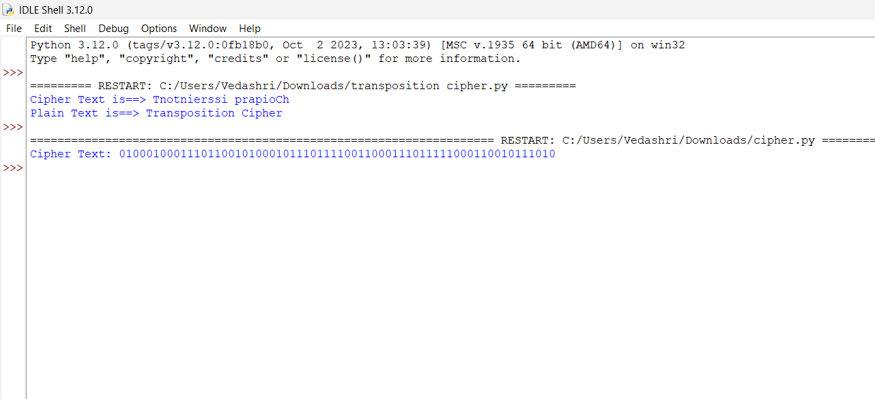
print("Cipher Text:", des_encrypt(plaintext, key))

